WEEK -1
DAY-1:
PROJECT OVERVIEW
Receipt & Invoice Digitizer
Convert a photo or PDF of a bill into structured data like:
Vendor Name
Date
Invoice Number
Line Items (item, qty, price)
Total Amount
Tax
This is Document AI + OCR + Information Extraction.
What is OCR?
Optical Character Recognition = converting image text → machine-readable text
DAY-2
TEAMS DIVIDING AND PROJECT DISCUSSION IN DETAIL
ASKED UD TO UNDERSTAND REGARDING PROJECT
In detail view regarding the project
Milestone and the workflow
Tech stacks and all

Day 3
git :it is a version control system
it is usef for file changes.
it is mainly runs on our local machine.
GitHub:it is a platfor that hosts git repositories.
it pulls codes,files,collborations.
git lab: it is an anoher platform like github.
it doent rns locally.
Git commands
1)git main---it is a branch name
2)git add.----it is a command used to move changes into the staging area before committing
3)git add file-----it is for one specific so it can be included
4)git branch branch name ----it is used to create a branch name
5)git pull
6)git push
7)pip install -r requirements.txt
8)git commit -m message
9)git add python
10)python -m venv snehitha
Git –version ----returns out the current version of the git using presently
Git fetch:
Downloads changes from remote
Does NOT modify your working files
Git pull:
Downloads changes
Immediately merges them into your current branch
Virtual machine
-python virtual machine
It is mainly used to create ,control,and manage

PRACTICAL :CREATING GITHUB REPOSITORY

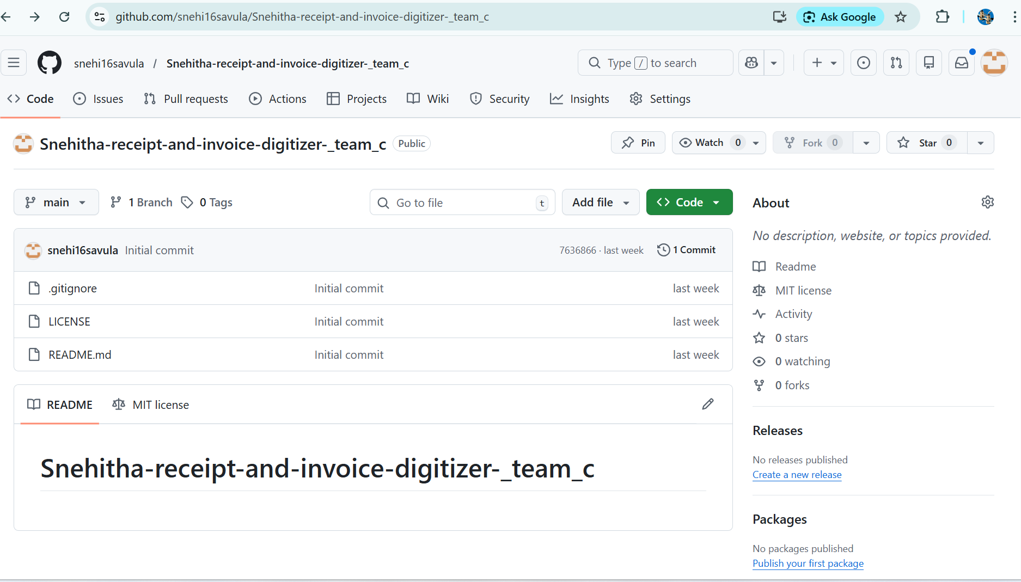

DAY-4

SDLC:
Software Development Life Cycl is a structured process used to design, develop, test, and deploy software systematically to ensure quality, cost control, and timely delivery.

DIFFERENT ROLES OF SDLC:
1) Functional Analyst :
2) Developer
3) Tester
4) Marketing
5) Sales
6) Human Resources
7) Documentation Team

DETAILED EXPLANATION
Functional Analyst :
A Functional Analyst gathers business requirements from clients, translates them into functional specifications
Developer :
A Developer is a professional who designs, writes, tests, and maintains code to build software applications based on given requirements and technical specifications.
Tester :
A Tester is responsible for verifying and validating software by identifying bugs, ensuring functionality works as expected
Marketing:
Marketing focuses on creating awareness, generating interest, and attracting potential customers through research, advertising, branding, and promotion.
Sales:
Sales focuses on converting interested customers into actual buyers by directly communicating, negotiating, and closing deals.
Human Resources :
Human Resources is the department responsible for recruiting, training, managing employee relations,
Documentation Team:
The Documentation Team is responsible for preparing, organizing, and maintaining project-related documents such as requirements

DIFFERENT MODELS SUPPORTING SDLCC;
Waterfall Model:
The Waterfall Model is a linear SDLC approach where each phase is completed fully before moving to the next, with minimal scope for changes once a phase is finished
Agile Methodology:
Agile is an iterative software development approach where work is divided into small cycles , with continuous feedback, collaboration, and flexibility to accommodate changes quickly.
OTHER THINGS:
POC ---Proof of Concept:
POC is a small-scale implementation built to test
EOD -------End of Day:
EOD means the close of business hours for a particular day,
SOD --------Start of Day:
SOD refers to the beginning of business hours when work activities officially start.
Day-5
Assignment-1
Create a python code which is using the fast or flask API
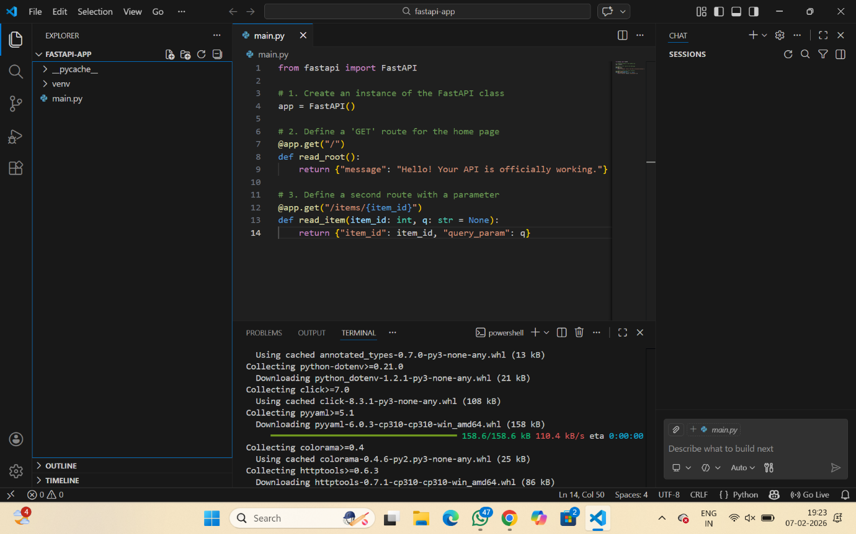
THIS IS THE API INTEGRATION WE HAVE DONE IN DAY-5
- FLASK API
- APP=Flask(_name)
- @app.route()
- App=Flask(_name_)
- Flask—create app
- Request—payload
- Jsonify—payload
- Fast api
- From fastapi import Fastapi
- App=FASTAPI()
- @app.get()
- @app.post()

Postman-Tool which is used to test the API
Https reuest
Web socket
Async functions

